**COSC 32133**

**Lab Sheet 02**

**PS/2021/211**

**H.M.B Prabhath**

**Part A**

**Index.html**

<html><head>

    <title>Home Page</title>

</head>

<body>

<h2>This is my Home Page</h2>

</body>

</html>

**Part B**



**Part C**

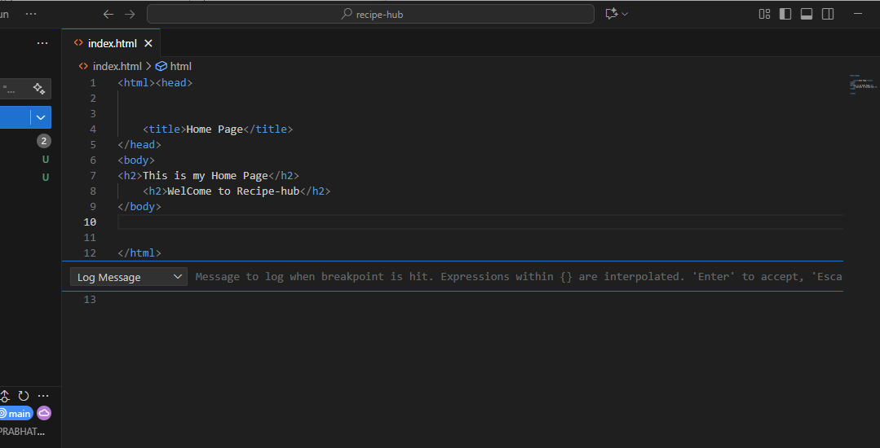

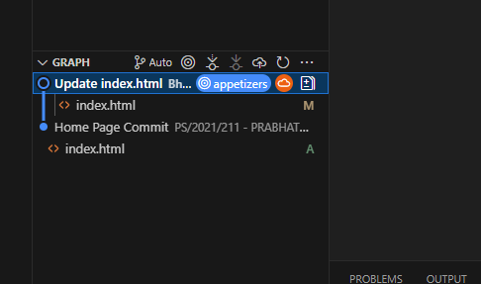

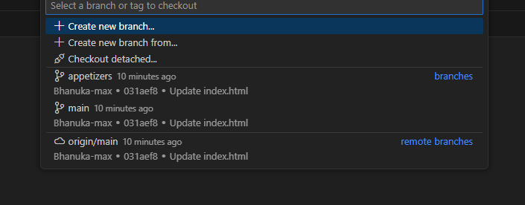

**appetizers.html**

<html>

 <head>

    <title>Appetizers Recipes</title>

 </head>

    <body>

            <h1>Roasted Tomato & Boursin Cheese Dip</h1>

<p>A creamy, tangy dip that’s perfect with crackers or crostini.</p>

<h1>Ingredients</h1>

<pre>

1 pint cherry tomatoes

1 block Boursin cheese (Garlic & Fine Herbs recommended)

</pre>

<h1>

Steps</h1>

<pre>

Preheat oven to 375°F (190°C).

Slice cherry tomatoes in half and place in a shallow baking dish.

Drizzle with olive oil, season with salt and pepper, and roast for 20 minutes until blistered.

Add the Boursin cheese to the dish, break it up slightly with a spoon.

Return to oven for 5 more minutes until cheese is melty.

Stir everything together into a creamy dip and serve warm with crackers or pita chips

   </pre>

   <h1>Bacon-Wrapped Asparagus Spears</h1>

   <p>A savory, smoky bite-sized treat that’s easy to prep and grill.</p>

<h1>Ingredients</h1>

<pre>Fresh asparagus spears (trimmed)

Thinly sliced bacon</pre>

<h1>Steps</h1>

<pre>Wrap each asparagus spear tightly with a slice of bacon.

Place on a baking sheet or grill pan.

Grill or bake at 400°F (200°C) for 15–20 minutes until bacon is crispy and asparagus is tender.

Serve immediately as finger food or with a dipping sauce of your choice</pre>

    </body>

</html>